Wap to find the factorial of a number

Wap to find the Fibonacci series of a number

What is the difference between recursion and iteration

Wap to reverse a string using recursion..

1. Write a recursive function to search for an element in an array
2. Write a recursive function to count the digits of a positive integer (do also for sum of digits)
3. Write a recursive function to reverse a null-terminated string
4. Write a recursive function to convert a decimal number to binary
5. Write a recursive function to check if a string is a palindrome or not
6. Write a recursive function to copy one array to another

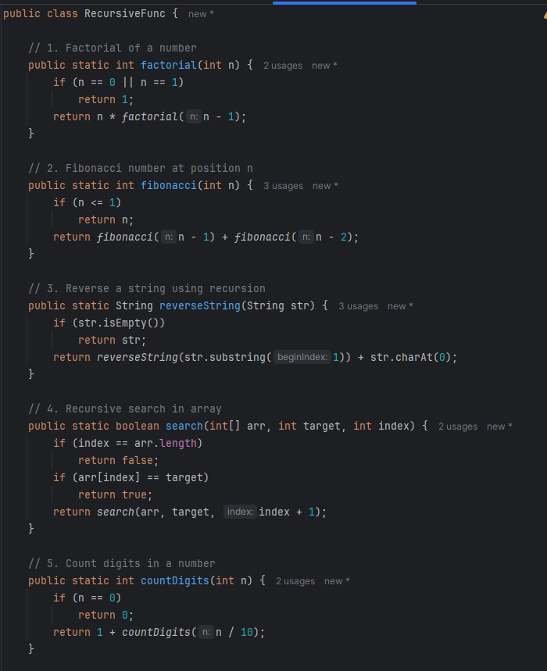
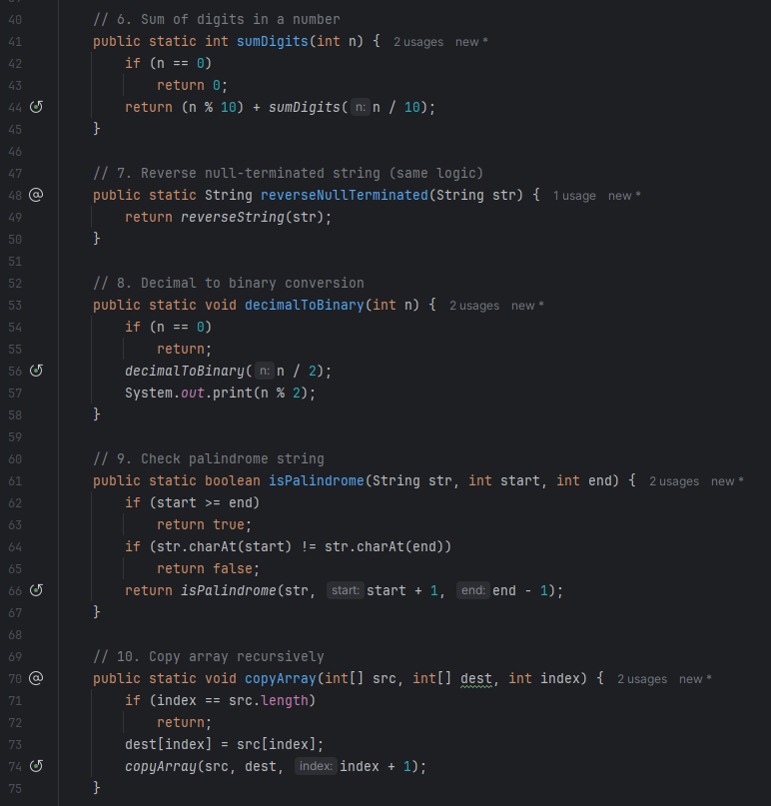
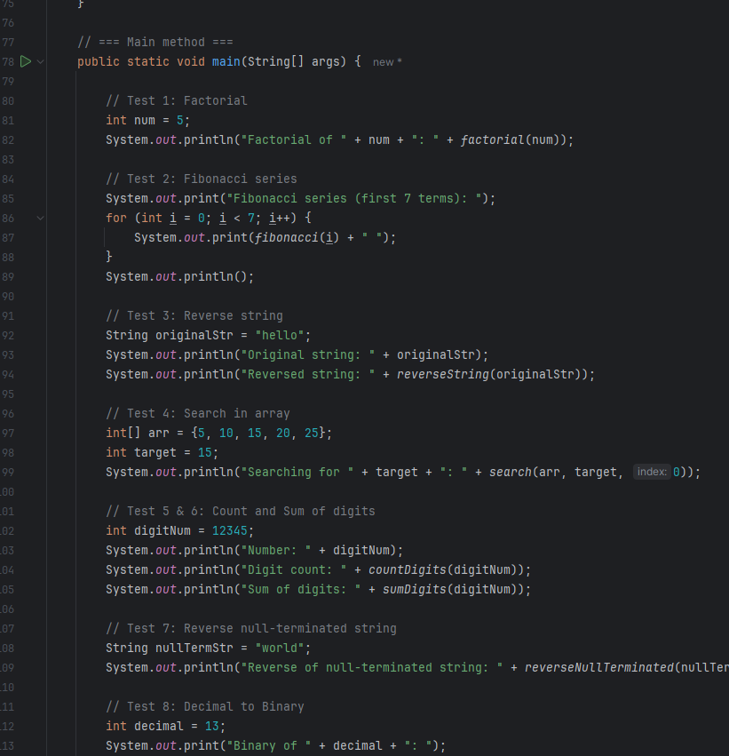
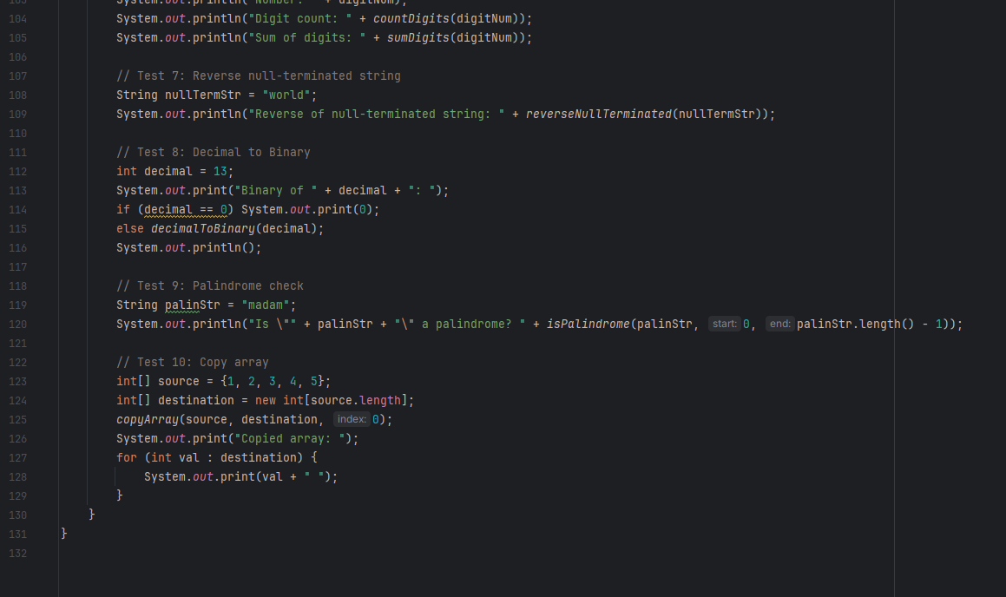
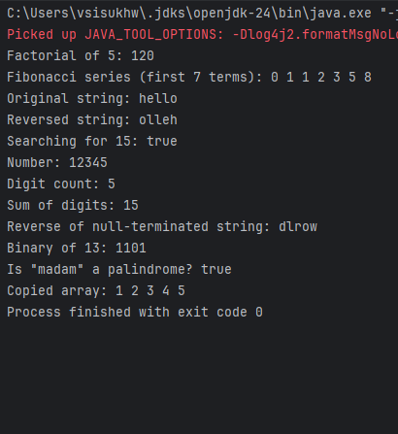

Difference between Recursion and Iteration

Iteration:
- Definition: Repetition using loops (for, while, do-while).
- Mechanism: Continues looping until a condition fails.
- Memory Usage: Efficient; uses constant memory.
- Speed: Generally faster due to less overhead.
- Termination: Controlled by loop conditions.
- Example: Looping through an array using a for loop.

Recursion:
- Definition: A function calls itself to break down the problem.
- Mechanism: Solves smaller instances of the same problem.
- Memory Usage: Uses stack memory for each recursive call.
- Speed: Can be slower due to function call overhead.
- Termination: Requires a base case to stop recursion.
- Example: Calculating factorial with n * factorial(n - 1).

